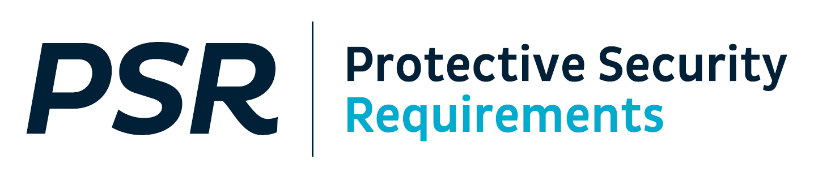

**PREPARE TO ASSESS YOUR PROTECTIVE SECURITY CAPABILITY 2024/25**

Kia ora koutou

The annual Protective Security Requirements (PSR) capability self-assessment round is now open.

Your Chief Executive is responsible for the self-assessment and final sign off of the report, which must be submitted to psr@protectivesecurity.govt.nz by 30 April 2025.

Below is a summary of what you need to know before you assess your capability this round.

# What documents are available for the 2024/25 round?

The 2024/25 PSR self-assessment round documentation comprises the following documents.

For completion and submission by 30 April 2025:

* A reporting template
* An excel spreadsheet for recording policy documentation, as an alternative to recording this detail in the reporting template

For completion but not submission:

* A capability maturity assessment template

For information

* A reporting guide, demonstrating how the 2024/25 PSR Annual Self-Assessment Report template should be used to support the rating you have assessed for each mandatory requirement.
* This information sheet.

# Which documents should my agency use?

Two different processes and sets of templates will be used in the 2024/25 reporting round.

* **Agencies participating in the pilot** of a new approach to PSR assurance will be provided with a separate, draft self-assessment tool and guidance. These documents are not available on the PSR website.
* **All other agencies** should use the templates outlined in this document and available for download from [the PSR website](https://www.protectivesecurity.govt.nz/about/self-assessment-and-reporting).

# What has changed?

This year’s reporting template is the same as the template used in 2023/24, with the exception of the following minor updates.

**The 2022 Classification System policy and procurement-related questions asked on behalf of MBIE have been removed.** These have now been incorporated into the Assurance Framework, and references have been added to the self-assessment prompts in order to help you complete your assessment of the relevant mandatory requirements.

**The *Feedback on the PSR Self-Assessment* question in the Chief Security Officer’s summary for the Chief Executive has been removed**. As this is the last year the interim templates will be used we have taken this question out of the summary, but the question asking if you require any PSR Unit support remains if your agency has any specific feedback it would like to share with us.

# What hasn’t changed?

**The Capability Maturity Model (CMM) assessment section of the PSR Self-Assessment Report Template is still in a separate Capability Maturity Assessment Template**.

The Capability Maturity Assessment Template is for your agency’s internal use when you undertake your CMM assessment. You must still undertake this capability assessment and summarise your findings in your self-assessment report, however you will not need to provide the detailed evidence in your self-assessment report. This will reduce some of the duplication you have experienced when reporting. You do not need to submit this.

**Your self-assessment must be submitted via email.** Please contact the PSR Unit for advice on submission processes if your agency’s report is classified C*NFIDENTIAL or above.

**The “How To” Guide provides examples of what good evidence looks like.** The guide was produced to demonstrate what is required to evidence the policy and practice for mandatory requirements. It provides real world anonymised examples. Combined with the updated PSR Self-Assessment Report Template, these tools should allow you to better understand what good evidence looks like. It should also improve consistency of reporting across agencies. This year it has been updated to align with the minor changes to the reporting template, and provides a model example in INFOSEC to support answering those questions.

The optional[**excel spreadsheet**](https://www.protectivesecurity.govt.nz/assets/Governance/agency-supporting-documentation-2023-24.xlsx)remains available for recording policy documentation.

**Moderation of your self-assessment improves the quality and accuracy of your reporting**. As always, we encourage you to have your self-assessment moderated.

If you have any questions, please contact the PSR team on:

[psr@protectivesecurity.govt.nz](mailto:psr@protectivesecurity.govt.nz).

Ngā mihi nui ki a koutou

Protective Security Requirements Team

cid:image003.png@01D8C783.1CCCB2D0